ASSIGNMENT NO. 5
K-Nearest Neighbours (KNN) Classification

Aim
To classify data with the K-Nearest Neighbours (KNN) algorithm and find the best value of k.

Objectives
- Understand how KNN decides the class of a new point.
- Learn the distance measures KNN can use.
- See how changing k affects accuracy.
- Evaluate the final model with a confusion matrix and classification report.

Software and tools
Python 3, written and run in Jupyter Notebook (VS Code works too) on Windows. Libraries used: matplotlib and scikit-learn.

Theory

1. The idea behind KNN
KNN is one of the easiest algorithms to follow. Similar things tend to sit close together, so to classify a new point, KNN looks at the k training points nearest to it and goes with the majority. It's like moving to a new area and guessing what language people speak by asking your nearest neighbours.

2. A lazy learner
Most algorithms build a model while training. KNN doesn't. It just stores the training data and does all its work when asked to predict, which is why it's called a lazy (or instance-based) learner.

3. Steps of the algorithm
- Choose the number of neighbours, k.
- Work out the distance from the new point to every training point.
- Sort the distances and take the k closest points.
- Count the classes of these k neighbours.
- Give the new point the class that comes up most often.

4. Distance measures
Euclidean distance, the straight-line distance, is the default:
d = √[ Σ (xᵢ − yᵢ)² ]
Manhattan distance only moves along grid lines, like walking city blocks:
d = Σ | xᵢ − yᵢ |
Minkowski distance covers both. With p = 1 it's Manhattan, and with p = 2 it's Euclidean.

5. Choosing k
With a very small k, like 1, a single noisy point can flip the answer and the model overfits. With a very large k, far-off points get a vote too and the model underfits. For two classes, an odd k avoids tied votes. In practice we try a range of values and keep whichever scores best on the test data.

6. Why scaling matters
KNN runs entirely on distance. If area is in the thousands and smoothness is between 0 and 1, area decides almost everything. So the features always get scaled first.

7. Advantages and disadvantages
Advantages | Disadvantages
Very easy to understand and code | Predictions are slow on large datasets
No training time | Has to keep all the training data in memory
Works with more than two classes | Sensitive to feature scale and noisy points
Can also be used for regression | Struggles when there are too many features

Dataset used
The Breast Cancer Wisconsin dataset from scikit-learn: 569 samples, 30 numeric features measured from images of cell nuclei, each labelled malignant (212 samples) or benign (357 samples). We used 75% for training and 25%, which is 143 samples, for testing.

Procedure
- Import the libraries and load the dataset.
- Split the data into training and testing sets.
- Scale the features with StandardScaler, fitting it on the training data only.
- Train KNN for every k from 1 to 20 and store the test accuracy.
- Plot accuracy against k and pick the best k.
- Train the final model with that k and predict the test data.
- Print the accuracy, confusion matrix and classification report.

Program
# Assignment 5 - KNN classification
import matplotlib.pyplot as plt
from sklearn.datasets import load_breast_cancer
from sklearn.model_selection import train_test_split
from sklearn.preprocessing import StandardScaler
from sklearn.neighbors import KNeighborsClassifier
from sklearn.metrics import accuracy_score, confusion_matrix, classification_report

data = load_breast_cancer()
X_train, X_test, y_train, y_test = train_test_split(
data.data, data.target, test_size=0.25, random_state=42, stratify=data.target)

# KNN works on distance, so scaling is a must
scaler = StandardScaler()
X_train = scaler.fit_transform(X_train)
X_test = scaler.transform(X_test)

# try k from 1 to 20 and note the accuracy
scores = []
for k in range(1, 21):
knn = KNeighborsClassifier(n_neighbors=k)
knn.fit(X_train, y_train)
scores.append(knn.score(X_test, y_test))

best_k = scores.index(max(scores)) + 1
print("Accuracy for k = 1 to 20:")
print([round(s, 3) for s in scores])
print("Best k:", best_k)

plt.figure(figsize=(6, 4))
plt.plot(range(1, 21), scores, marker='o')
plt.xlabel('k (number of neighbours)')
plt.ylabel('Test accuracy')
plt.title('Accuracy vs k')
plt.xticks(range(1, 21))
plt.tight_layout()
plt.savefig('a5_k.png')
plt.show()

# final model with the best k
knn = KNeighborsClassifier(n_neighbors=best_k)
knn.fit(X_train, y_train)
y_pred = knn.predict(X_test)

print("\nFinal accuracy:", round(accuracy_score(y_test, y_pred), 3))
print("\nConfusion Matrix:")
print(confusion_matrix(y_test, y_pred))
print("\nClassification Report:")
print(classification_report(y_test, y_pred, target_names=data.target_names))

Output
Accuracy for k = 1 to 20:
[0.951, 0.937, 0.972, 0.958, 0.979, 0.972, 0.979, 0.972, 0.965, 0.965, 0.972, 0.979, 0.958, 0.965, 0.958, 0.958, 0.951, 0.951, 0.951, 0.951]
Best k: 5

Final accuracy: 0.979

Confusion Matrix:
[[50 3]
[ 0 90]]

Classification Report:
precision recall f1-score support

malignant 1.00 0.94 0.97 53
benign 0.97 1.00 0.98 90

accuracy 0.98 143
macro avg 0.98 0.97 0.98 143
weighted avg 0.98 0.98 0.98 143

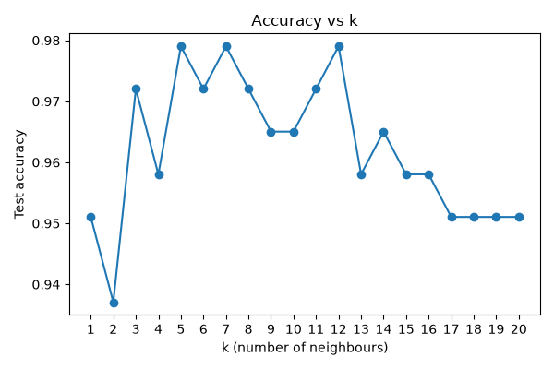
Figure 5.1: Test accuracy for each value of k

Observations
- Accuracy stayed between 0.937 and 0.979 for every k, so KNN suits this data well overall.
- The worst score was at k = 2 (0.937). Even values of k can cause tied votes, which may explain part of it.
- The best score, 0.979, first showed up at k = 5 and came up again at k = 7 and k = 12.
- Past k = 12, accuracy slowly drops as the model gets too general.
- The confusion matrix shows all 90 benign samples correct. 50 of the 53 malignant samples were correct and 3 were called benign.
- In medicine, missing a cancer case is worse than a false alarm, so the 0.94 recall for malignant is the number most worth improving.

Conclusion
After scaling the data and trying k from 1 to 20, k = 5 gave the best accuracy, about 98%. Very small and very large values of k both did worse. KNN needs no training and is easy to understand, but it only works well when the features are scaled and k is chosen with some care.

